TASK 1 : Execute a Linux Command Using fork() and exec()
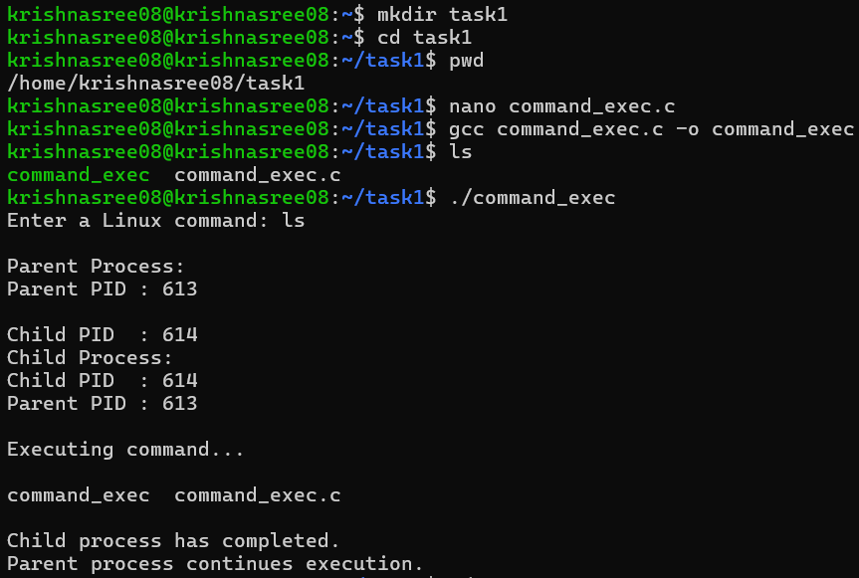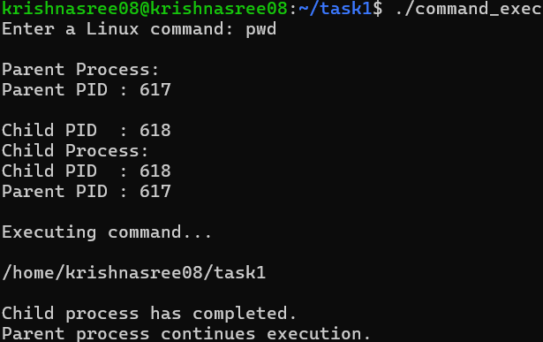
The program successfully demonstrated the basic process management mechanism in Linux. The fork() system call created a child process, while execvp() was used by the child to execute the command entered by the user. The PID of both processes was displayed using getpid() and getppid(). The parent process used wait() to wait for the child process to complete. The output confirms that the command was successfully executed by the child process.

Summary: In this task, a C program was developed to understand how Linux creates and manages processes. The fork() system call was used to create a child process, and execvp() was used by the child to execute the Linux command entered by the user. The getpid() and getppid() functions were used to display the process IDs, while wait() allowed the parent process to wait for the child to finish. This demonstrated the basic process creation and command execution mechanism in Linux.

TASK 2 : Hardware Resources and Operating System Services Aim
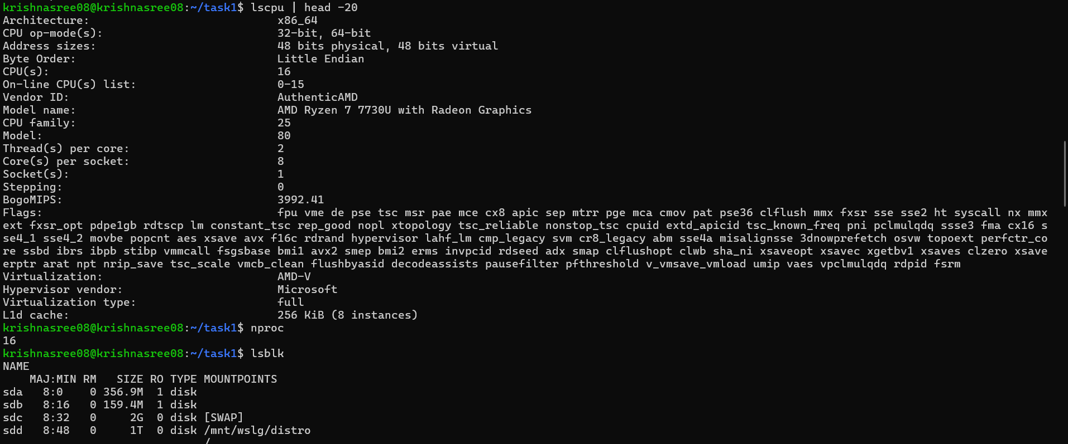
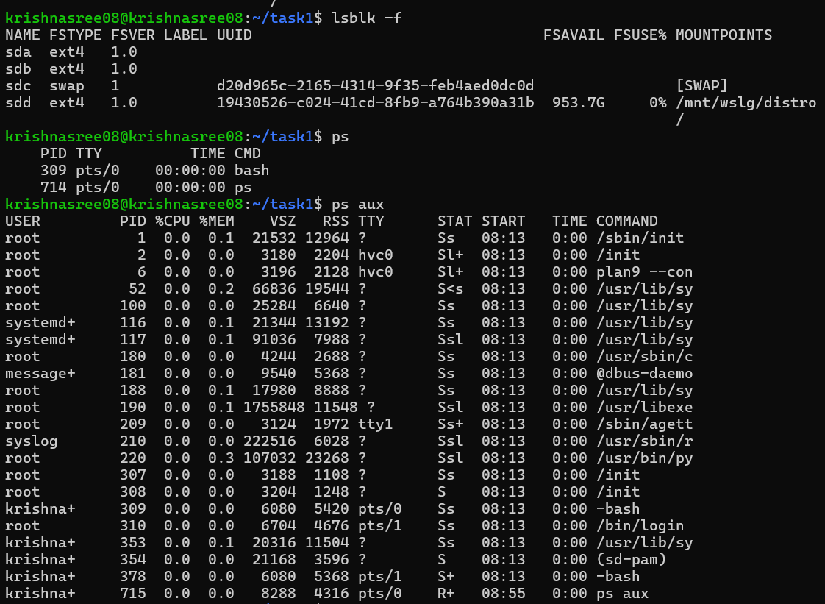
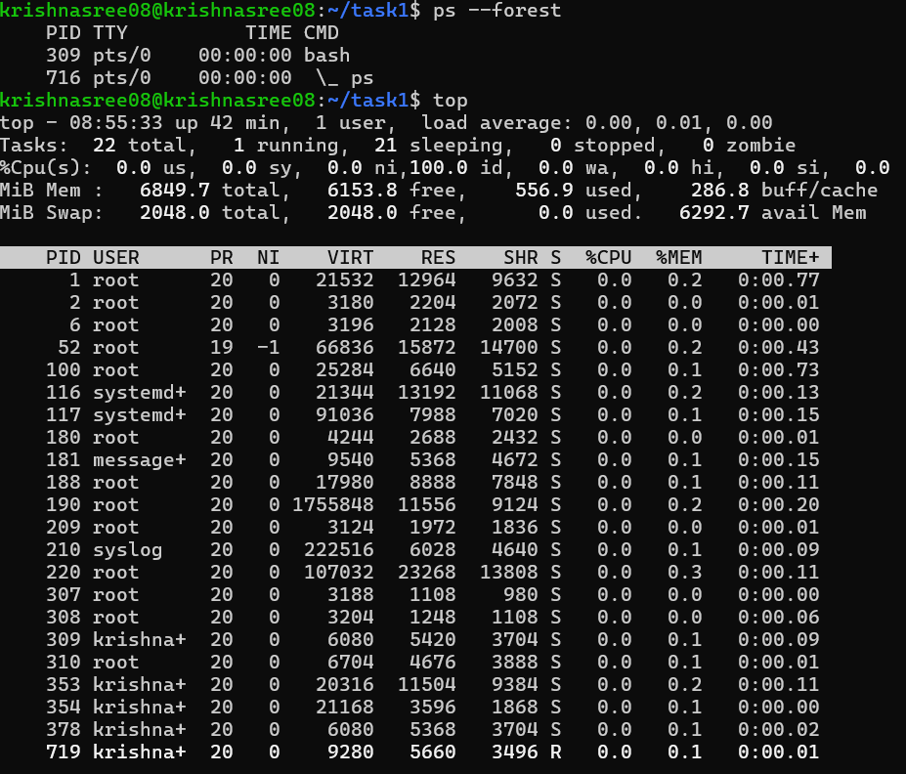
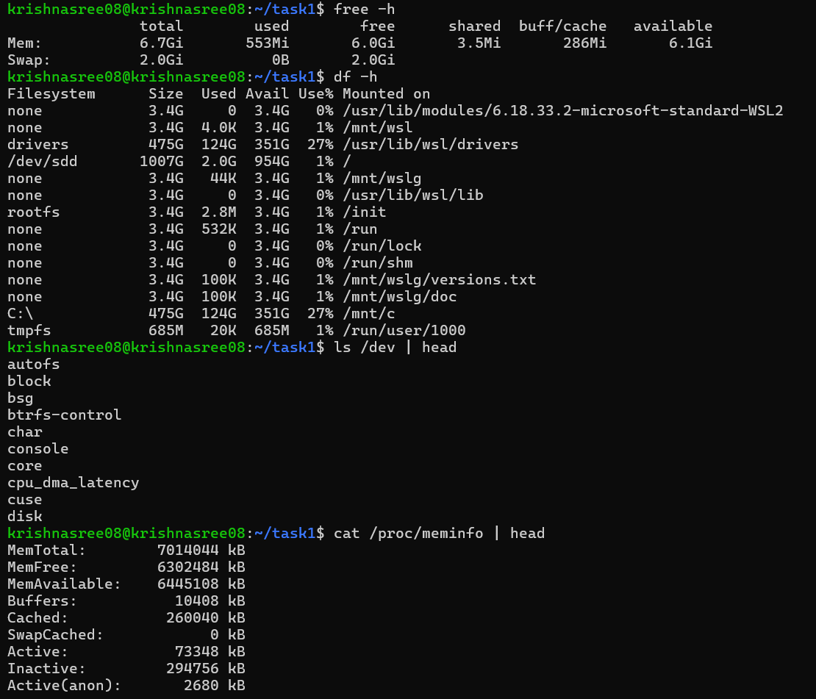
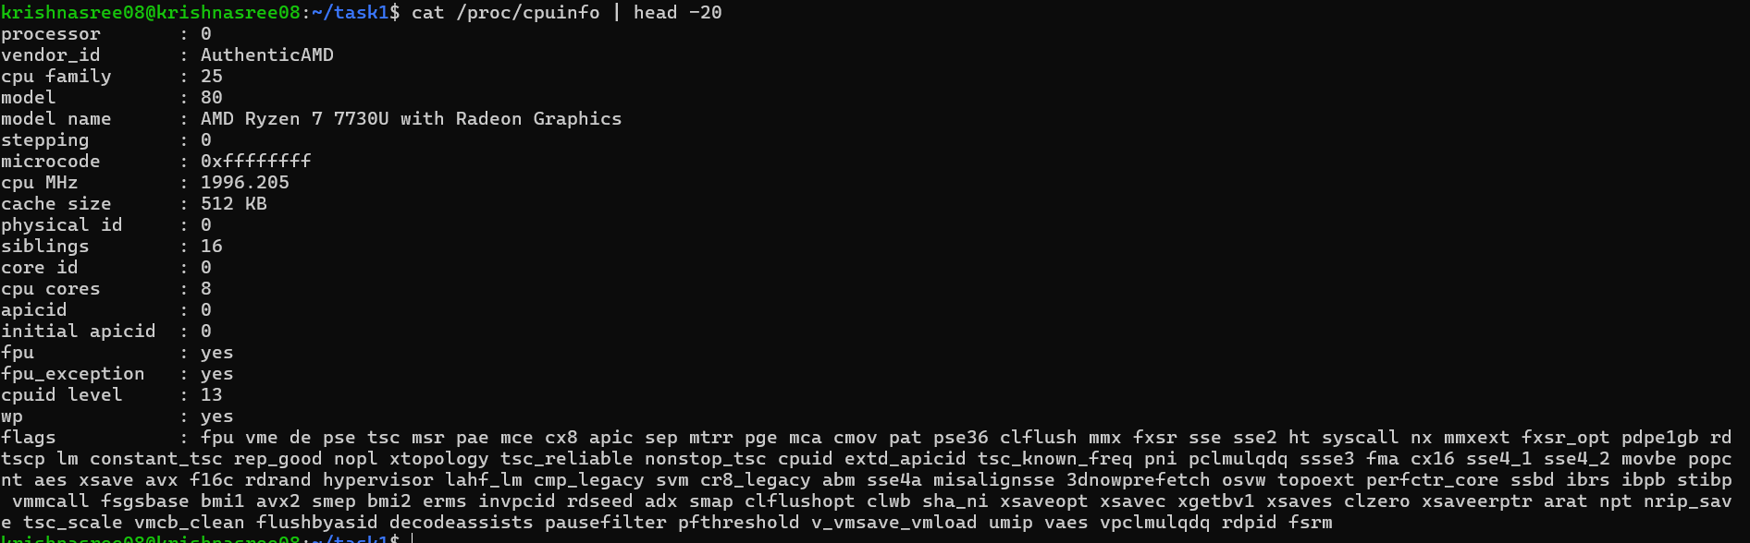
Thus, the relationship between hardware resources and operating system services was successfully investigated using Linux terminal commands. The role of Linux in managing CPU, memory, storage, processes and I/O devices was studied and understood.
Summary: In this task, different Linux commands were used to study the hardware resources and operating system services. Commands such as uname, lscpu, and lsblk were used to examine the operating system, CPU, and storage devices. ps and top were used to observe running processes, while free and df helped examine memory and storage usage. The /dev and /proc directories were also studied to understand how Linux provides abstractions for hardware and system resources.

